

Systems Development: Object Oriented Programming

(H171 35)

WPF Application

Step 1 – create the initial welcome screen

* We are going to create the initial startup page for when the application is launched. This can be created either by directly editing the XAML code or using the designer to drag and drop.

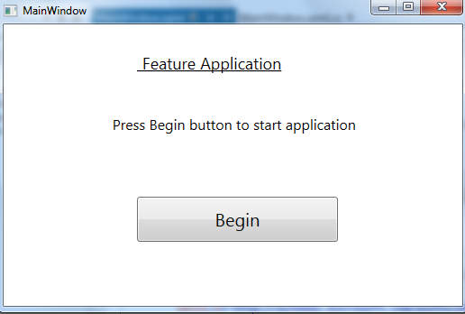

* Drag across:
* 2 textblocks
* 1 button named beginAppButton
* Edit the code behind file so that when the page is loaded the “Begin” button is in “focus” i.e. highlighted to the user

